**Fidelity Bahamas Optimist National Open Championship 2023**

**Friday, September 29th – Sunday, October 1nd,2023**

**Organizing Authorities: Nassau Yacht Club**

**The Bahamas Optimist Dinghy Association**

**and Bahamas Sailing Association**

**Nassau, Bahamas**

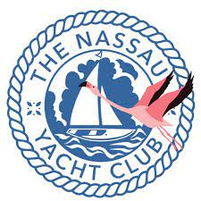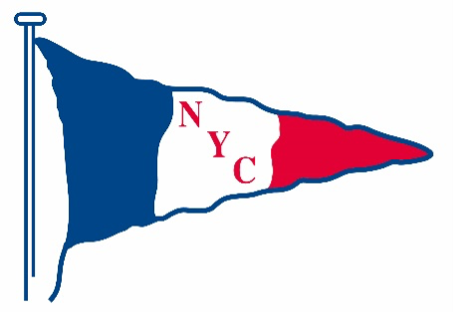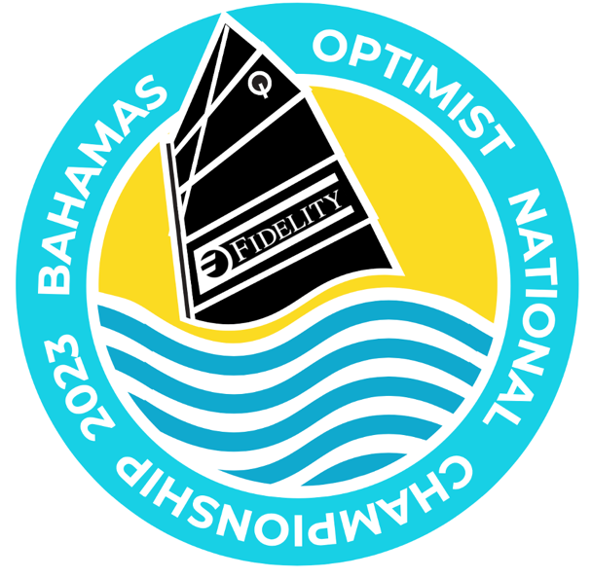

**Registration Form**

**PARTICIPANT’S INFORMATION**

______________________________________________________________________________

Participant - First Name

______________________________________________________________________________

Participant - Last Name

__________________________ _____________________ Gender:

Date of Birth Age on Sep. 30th, 2023 Male Female

______________________________________ __________________________________

Sail Number Club Affiliation

Fleet (age on the first day of racing):

Championship White - 10 and under (on September 30th, 2023)

Championship Blue - 11 or 12 (on September 30th, 2023)

Championship Red - 13, 14 or 15 (on September 30th, 2023)

Green Fleet

_____________________________________________________________________________

Dietary Restrictions

Youth Shirt Size Adult Shirt Size

Small Small

Medium Medium

Large Large

X-Large X-Large

**PARENT / GUARDIAN INFORMATION**

________________________________________________________________________

Parent / Guardian Full Name

________________________________________________________________________

Parent / Guardian Address

______________________________________ ______________________________

Home Phone Number Mobile Phone Number

______________________________________

Email

**FEES**

Early Registration – on or before September 15th, 2023              $130.00

Late Registration – on or after September 16th, 2023                    $150.00

IODA Membership $5.00

**PAYMENT FORM:**

Local:

Beneficiary: The Nassau Yacht Club

Beneficiary Bank: First Caribbean International Bank – Harbour Bay Branch

Branch #: 09766

Account #: 56900518

Reference text: Opti Nat 2023 Fees: (Skippers Name)

Wire:

USD

Correspondent Bank: Wells Fargo Bank, New York

SWIFT Code: PNBPUS3NNYC

ABA Code: 026005092

Beneficiary Bank: FirstCaribbean International Bank (Bahamas) Limited

SWIFT Code: FCIBBSNS

Beneficiary: The Nassau Yacht Club

Beneficiary Account Number: 56900518

Details for other currencies can be found here:

<https://www.cibcfcib.com/binaries/content/assets/wire-xfers/bahamas---wire-transfer-instructions.pdf>

Please note:

USD transactions direct to the Bahamas will be subject to a fixed exchange rate of USD $1 = BSD $0.995.

Any wire transfer balance must also include an additional amount of BSD $12.38 to account for processing by the bank in the Bahamas.

An example calculation would be:

Given 10 Early Registrations the BSD amount would be 10 x BSD $130.00 = BSD $1300

Total to be sent in USD: (USD $1300 + USD $12.38)/0.995 = USD $1318.97

**Medical Consent & Liability Release Agreement**

_____________________________________________ _________________________________________

Participant's First Name Participant's Last Name

______________________________ __________________________ __________________________

Allergies – Food Allergies – Medication Allergies – Other

In the event of accident, injury, or illness involving any child of mine, or any child in my care (specifically including the child named above as “Participant”), or myself, my spouse, or any other member of my family while participating in any activity sponsored by or under the auspices of The Nassau Yacht Club, the Bahamas Optimist Dinghy Association or the Bahamas Sailing Association (which three organizations are collectively referred to as “the said Organizations”), under circumstances where I am physically unable to consent, or am not present, I hereby voluntarily authorize and consent to the furnishing to the Participant, myself, my spouse, or any other member of my family, of such medical care, attention, and treatment by any hospital, clinic, physician or dentist as such hospital, clinic physician, or dentist may deem necessary or advisable, including x-ray examinations, anesthetic, medical or surgical diagnosis, or procedure.  I authorize any adult associated with the activity to consent to such medical care, attention, and treatment, I agree to pay the reasonable cost of such medical care, attention, or treatment and to indemnify and hold free and harmless, of and from, any and all liability for such cost the assisting adult, the said Organizations and their directors, officers, employees, members, and regatta volunteers.  It is understood that efforts shall be made to contact the undersigned prior to rendering treatment to the patient, but that any of the above treatment may be withheld if the undersigned can not be reached.

____________________________________________________ __________________________________

Primary Care Physician Physician’s Phone Number

____________________________________________________ __________________________________

Health Insurance Company Group Number (if applicable)

____________________________________________________ __________________________________

Name of Insured Policy Number

I agree that a photocopy of this consent, or a photocopy sent by facsimile, or pdf format file sent by e-mail attachment may be accepted by any healthcare provider.  This consent shall be valid for one (1) year from the date of signing.

**Emergency Information**

________________________________________________ ________________________________

Emergency Contact's Name Relationship to Participant

________________________________________________ ________________________________

Phone Number Alternative Number

In consideration of acceptance of the registration of the above “Participant” to participate in the regatta and recognizing the risks associated with the sport of sailing, the undersigned hereby waives all claims for personal injury and property damage and hereby indemnifies the said Organizations and all of their directors, officers, members, employees, regatta volunteers, and sponsors of and from any and all claims and liabilities of whatever kind, including those of negligence, which I or the “Participant” might have, arising out of participation in the regatta and all activities relating thereto.

I have read and agree to these terms.

________________________________________________ __________________________________

Parent/Guardian Date